Andrew Fagundes
Department of Information Technology, Western Governors University
D207 Exploratory Analysis
Professor William Sewell
June 12th, 2024

Table of Contents
Part I: Research Question and Variables 3
A1: Research Question 3
A2: How Can Stakeholders Benefit from the Analysis 3
A3: Data Set Identification 3
Part II: Data Analysis Techniques 5
B1: Techniques used in Python for Analysis 5
B2: Results from Data Analysis 5
B3: Technique Justification 6
Part III: Univariate Data Distribution 7
C1: Univariate Results 7
Part IV: Bivariate Data Distribution 13
D1: Bivariate Results 13
Part V: Data Analysis Implications 14
E1: Results of Hypothesis Test 14
E2: Limitations of Data Analysis 15
E3: Recommendations 16
References (No third party code references used) 17
Table of Figures 18

Part I: Research Question and Variables

A1: Research Question
For the medical data set, the research question is the following: “Is high blood pressure associated with patient readmission?” This question can help a hospital determine if a biomarker such as blood pressure is associated with patient readmission so that a preventative approach can be taken to reduce readmission in the future. Since we are dealing with two categorical variables in this data set, a Chi-Square test for independence will be used for the analysis.

A2: How Can Stakeholders Benefit from the Analysis
This analysis of the data is the first step in determining what factors may be influencing patient readmissions. By examining blood pressure, we can determine if patients are experiencing health related issues that is making them revisit the hospital more frequently. The identification of this variable allows us to determine if there is anyway the hospital can influence a patient’s health such as through blood work and supplement or food recommendations.

A3: Data Set Identification
Since the research question is specifically about the relationship between high blood pressure and hospital readmissions, these two columns will be used for the data analysis. These two variables are categorical, which means a chi-squared test must be used to answer the research question (Sewell 2024).
To assist in finding relevant variables for this exploratory analysis, we prepared the data in a few different ways. First, we checked the data for nulls and NAs. Next, we made sure to convert the ‘chr’ and ‘str’ data types to categorical. Then, we removed categorical that had a high cardinality based on the following formula: Cardinality > 3 to 5 levels (Sewell 2024).
For the univariate and bivariate statistics, two continuous and categorical variables must be used. The variables used are Income (continuous), Initial_days (continuous), Gender (categorical), and Area (categorical).

Part II: Data Analysis Techniques

B1: Techniques used in Python for Analysis
To analyze the research question, a Chi-Square test was used. The code is as follows:
#Contingency Table
cross_tab = pd.crosstab(medical_data_prepared['HighBlood'] ,medical_data_prepared['ReAdmis'])
cross_tab
#Chi-square test of independence of variables in a contingency table.
chi = stats.chi2_contingency(cross_tab)
print(chi)
print(f"The p-value, or probability under the null hypothesis of obtaining a result as extreme as the one observed, is {chi[1]:.3}.")
critical_value = stats.chi2.ppf(1-.05, df=1) # .05 is the alpha level, 95% certainty
print(f'Critical Value = {critical_value}') # Chi square stat is lower than critical value

B2: Results from Data Analysis
Given the results, we accept the null hypothesis because the Chi-Square statistic is less than the critical value and the p-value is greater than .05 (.83 is reported). The output was: 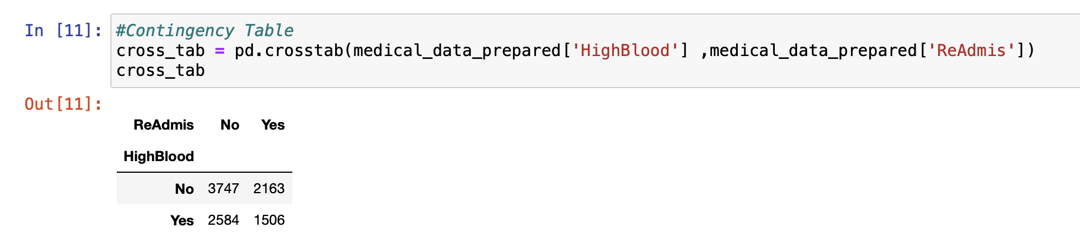
Figure 1: Contingency table between High Blood Pressure and Hospital Readmissions
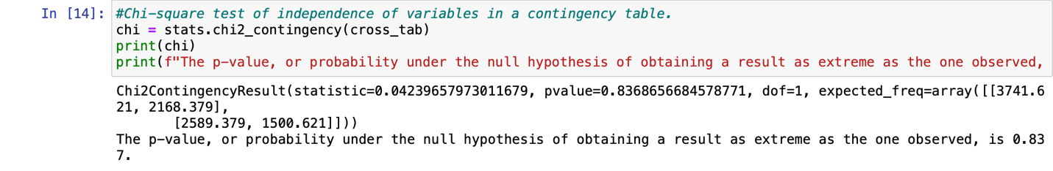
Figure 2: Chi-Square test of independence
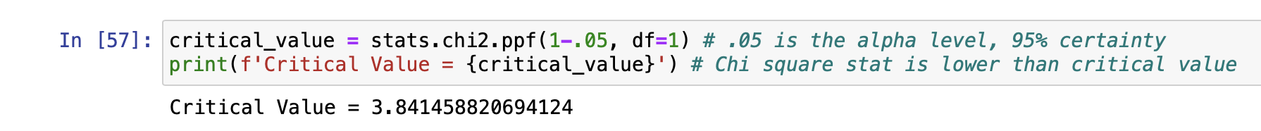
Figure 3: Critical value for Chi-Square test

B3: Technique Justification
The chi-square test was used because the variables analyzed, ReAdmis and HighBlood, are categorical. The type of chi-square test used is the ‘Test of Independence’ since the hospital wants to know if high blood pressure affects readmission rates. The chi-square test for independence is also used because we are not comparing the categorical variables to an expected value table, which means a chi-square goodness-of-fit test cannot be used (Turney, 2023). Another reason is because normality of data applies to quantitative data, not qualitative data like the variables used to answer this question (Bevans, 2023). Thus, this assumption of normality is violated, and parametric tests cannot be used. This means we use this test against a null hypothesis. The null hypothesis is as follows, H₀: The factors are independent. If we fail to reject H₀ then we know that these variables are independent and are not influenced by each other. If H₀ is rejected, then we know that the two variables are dependent on one another, and the hospital should focus on a patient’s high blood pressure to help reduce readmission rates to provide better care and avoid penalties.

Part III: Univariate Data Distribution

C1: Univariate Results
For the univariate analysis, we will be analyzing the continuous variables, Income and Initial_days, along with the categorical variables, Gender and Area. Density plots were used for both continuous variables and histograms were used for the categorical variables. Box plots were also used to detect the outliers of the continuous variables.
For the continuous variables, Income displayed a positively right skewed distribution while Initial_days displayed a bimodal distribution. For the categorical variables, Gender and Area were both uniformly distributed.
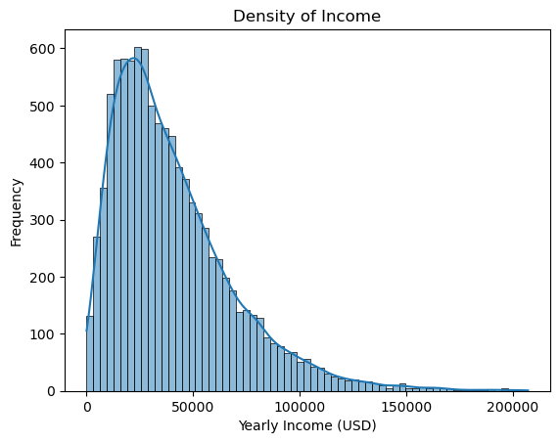
Figure 4: Density of Income
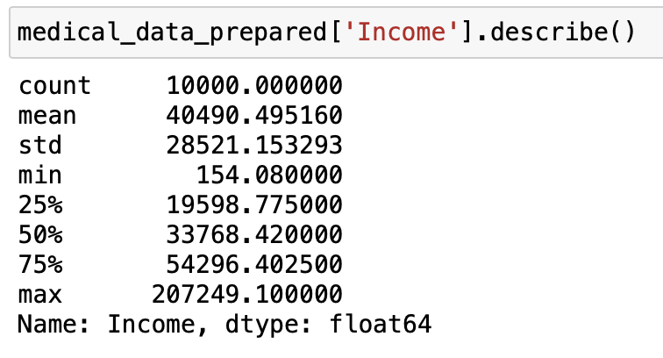
Figure 5: Summary Stats for Income
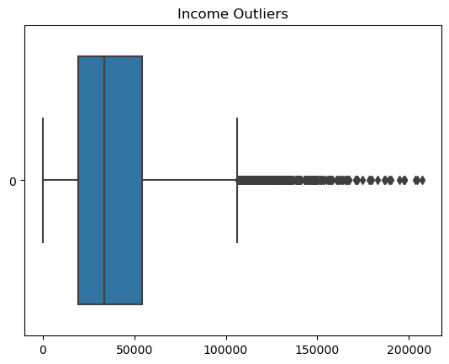
Figure 6: Outlier Detection for Income
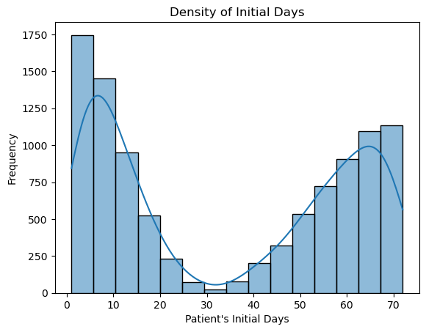
Figure 7: Density of Initial Days
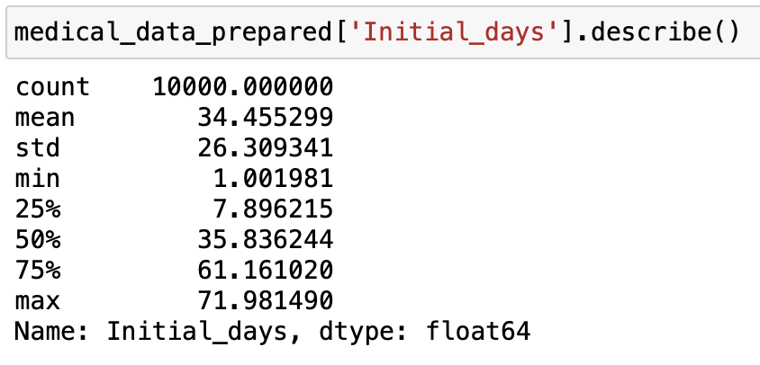
Figure 8: Summary Stats for Initial Days
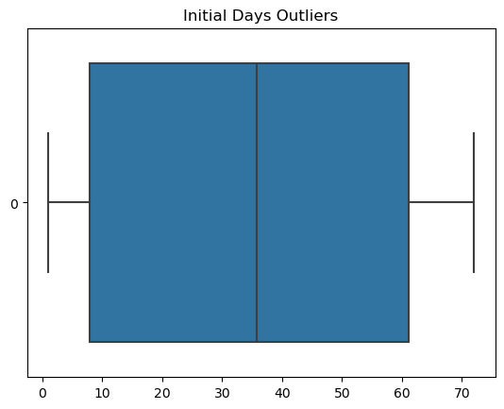
Figure 9: Outlier Detection for Initial Days
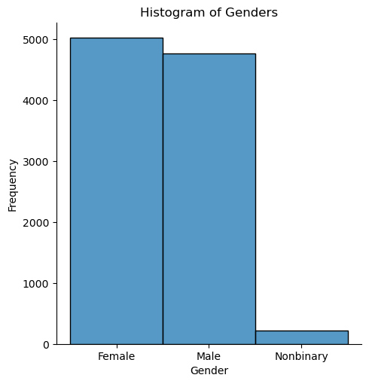
Figure 10: Histogram of Genders
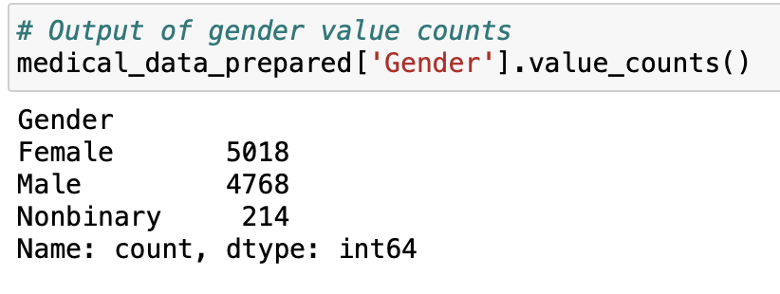
Figure 11: Total Values for Gender
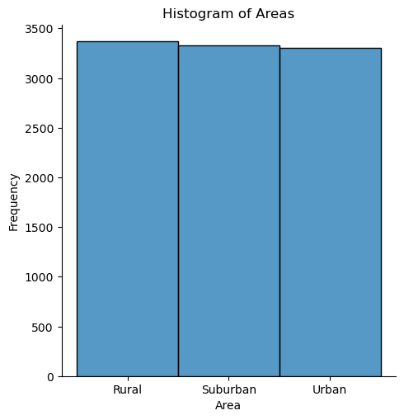
Figure 12: Histogram of Areas
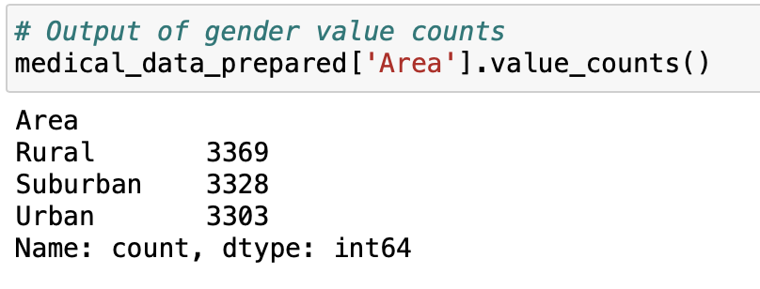
Figure 13: Total Values for Area

Part IV: Bivariate Data Distribution

D1: Bivariate Results
In the scatterplot between Income and Initial Days, we can see that there were more initial days spent in the hospital with lower incomes ranging from $0-50,000. As income increases, it seems that the richer people spend more time in the hospital. For our gender versus area graph, we can see that overall, there were more females than males hospitalized. Gender is normally distributed when area is used to as a second variable in the bivariate distribution.
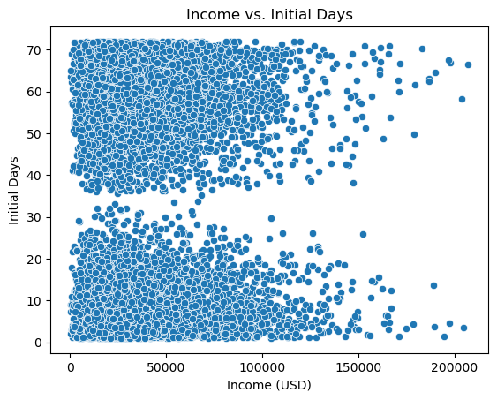
Figure 14: Scatterplot between Income and Initial Days
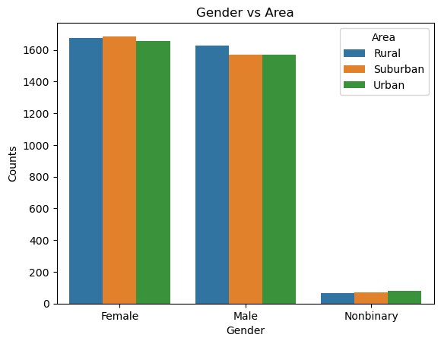
Figure 15: Count plot between Gender and Area

Part V: Data Analysis Implications

E1: Results of Hypothesis Test
The alpha level set for this Chi-Square test for independence was 0.05, the default for this test. This is the level the p-value must be lower than to show a statistically significant difference indicating that high blood pressure has a relationship with readmission. A p-value below 0.05 would indicate this with 95% certainty. The p-value returned by the chi-square test was 0.836, which is much higher than the alpha level. Thus, the null hypothesis must be accepted – these two variables are independent from each other. In other words, the proportion of people readmitted is the same for those with high blood pressure and those without. With such a high p-value, this is an observation that can be made with some confidence. A p-value of 0.836 implies that if the null hypothesis is true, there is an 83.6% chance of observing the difference the test statistic describes (Bevans, 2023).

E2: Limitations of Data Analysis
Since non-parametric tests such as the Chi-Square test make fewer assumptions than parametric tests, inferences made with these tests aren’t as strong as those made by parametric tests (Bevans, 2023).
In addition to its limitations as a non-parametric test, there are also some limitations of the chi-square test specifically. The chi-square test’s sensitivity to sample size can be problematic. If a sample size is large enough, a chi-square test can return outputs that indicate a statistically significant relationship where there is none (Chi-Square – Sociology 3112 – Department of Sociology – the University of Utah, n.d.). The sample size must also not be too small, as any given cell in the contingency table cannot be below 5. For my data analysis, the sample size was not too small, but it is possible that it may have been too large considering the data set has 10,000 observations, which reduces my confidence in the result despite the test showing no statistically significant relationship. It would be more concerning if there was a statistically significant relationship in the Chi-Square analysis as this limitation of the Chi-Square test would create false positives, also known as type I errors, rather than false negatives.
A chi-square test can be useful but only if a research question is asking about only categorical variables, otherwise it is futile. This is why a chi-square test was used based on the research question that was being asked. The downside of using this test is that it does not account for the continuous variables in this data set which means that we do not get a complete analysis of what variables may be associated with hospital readmissions.

E3: Recommendations
Since the null hypothesis was accepted, no changes are recommended to the hospital based on the independence between high blood pressure and hospital readmissions. Given the large sample size, one recommendation would be to run the chi-square test on a smaller sample or run a test better suited for large sample sizes. The sample should be large enough to satisfy the conditions required by a chi-square, which would avoid the oversensitivity issue and obtain a more accurate result.
Another recommendation would be to run more analysis on other variables in the cleaned data set, which could include more chi-square tests on the other categorical variables. This could potentially uncover a relationship between one of those variables and readmission.

References (No third party code references used)
Sewell (2024). Webinar for Exploratory Analysis. Retrieved from https://wgu.hosted.panopto.com/Panopto/Pages/Viewer.aspx?id=3980b7aa-6bdb-4b38-8356-ae3100e4ff55, https://wgu.hosted.panopto.com/Panopto/Pages/Viewer.aspx?id=958f4551-c08f-4611-ab2a-b109003ab67a
Bevans, R. (2023, June 22). Choosing the right statistical test | Types & examples. Scribbr. https://www.scribbr.com/statistics/statistical-tests/
Chi-Square – Sociology 3112 – Department of Sociology – The University of Utah. (n.d.). https://soc.utah.edu/sociology3112/chi-square.php
Turney, S. (2023, June 22). Chi-Square (X2) Tests | Types, Formula & Examples. Scribbr. https://scribbr.com/statistics/chi-square-tests/.

Table of Figures
Figure 1: Contingency table between High Blood Pressure and Hospital Readmissions 5
Figure 2: Chi-Square test of independence 6
Figure 3: Critical value for Chi-Square test 6
Figure 4: Density of Income 7
Figure 5: Summary Stats for Income 8
Figure 6: Outlier Detection for Income 8
Figure 7: Density of Initial Days 9
Figure 8: Summary Stats for Initial Days 9
Figure 9: Outlier Detection for Initial Days 10
Figure 10: Histogram of Genders 11
Figure 11: Total Values for Gender 11
Figure 12: Histogram of Areas 12
Figure 13: Total Values for Area 12
Figure 14: Scatterplot between Income and Initial Days 13
Figure 15: Count plot between Gender and Area 14

